Name: B. Alekhya

Reg no: 192411010

FINAL ASSESMENT

Analytical Study and Implementation of Brute Force Algorithms

1. Problem Understanding and Formulation
The given problem requires applying Brute Force techniques to sorting and searching.
Given array:
A = {42, 17, 8, 93, 26, 55, 11, 68, 34, 5, 79, 21}
The two problems are:
- Selection Sort – Sort all elements in ascending order.
- Sequential Search – Search for the key value 68.

Input
- An array containing 12 integers.
- Search key = 68.

Output
- Sorted array using Selection Sort.
- Position of 68 using Sequential Search.
- Number of comparisons and swaps.
- Time and space complexity.
- Performance comparison with efficient algorithms.

Constraints
The solution should correctly handle different input sizes and should be tested on larger datasets from approximately 10³ to 10⁶ records, as required in the assignment.

2. Selection Sort Using Brute Force
Selection Sort is a simple brute-force sorting algorithm. It divides the array into two portions:
- Sorted portion
- Unsorted portion
In every pass, the algorithm searches the unsorted portion to find the smallest element. It then places that element at the beginning of the unsorted portion.

Example
Initial array:
42 17 8 93 26 55 11 68 34 5 79 21

Major Passes
Pass | Array after placing minimum
Initial | 42, 17, 8, 93, 26, 55, 11, 68, 34, 5, 79, 21
1 | 5, 17, 8, 93, 26, 55, 11, 68, 34, 42, 79, 21
2 | 5, 8, 17, 93, 26, 55, 11, 68, 34, 42, 79, 21
3 | 5, 8, 11, 93, 26, 55, 17, 68, 34, 42, 79, 21
4 | 5, 8, 11, 17, 26, 55, 93, 68, 34, 42, 79, 21
5 | 5, 8, 11, 17, 21, 55, 93, 68, 34, 42, 79, 26
6 | 5, 8, 11, 17, 21, 26, 93, 68, 34, 42, 79, 55
7 | 5, 8, 11, 17, 21, 26, 34, 68, 93, 42, 79, 55
8 | 5, 8, 11, 17, 21, 26, 34, 42, 93, 68, 79, 55
9 | 5, 8, 11, 17, 21, 26, 34, 42, 55, 68, 79, 93
10 | 5, 8, 11, 17, 21, 26, 34, 42, 55, 68, 79, 93
11 | 5, 8, 11, 17, 21, 26, 34, 42, 55, 68, 79, 93

Final Sorted Sequence
5, 8, 11, 17, 21, 26, 34, 42, 55, 68, 79, 93

3. Selection Sort Pseudocode
SelectionSort(A, n)

for i = 0 to n-2
min = i

for j = i+1 to n-1
if A[j] < A[min]
min = j

if min != i
swap A[i] and A[min]

return A

Working
- Start from the first element.
- Assume it is the minimum.
- Compare it with all remaining elements.
- Find the actual minimum.
- Swap it with the first unsorted element.
- Repeat until the array is sorted.

4. Number of Comparisons in Selection Sort
For n = 12, comparisons are:
(n−1)+(n−2)+(n−3)+...+1(n-1)+(n-2)+(n-3)+...+1
Therefore,
n(n−1)2\frac{n(n-1)}{2} =12(12−1)2=\frac{12(12-1)}{2} =12×112=\frac{12\times11}{2} =66=\boxed{66}
Therefore, Selection Sort performs 66 comparisons for the given input.

Swaps
A swap is performed when the minimum element is not already at the current position.
For the given input, the actual number of swaps can be counted from the implementation. The important distinction is:
- Comparison: Checking whether one element is smaller than another.
- Swap/Data movement: Moving an element to its correct position.
Selection Sort performs Θ(n²) comparisons, but only O(n) swaps.

5. Sequential Search
Sequential Search, also called Linear Search, checks each element from the beginning until the required element is found.
Search key:
68
Given array:
42, 17, 8, 93, 26, 55, 11, 68, 34, 5, 79, 21

Search Process
Comparison | Element | Result
1 | 42 | Not found
2 | 17 | Not found
3 | 8 | Not found
4 | 93 | Not found
5 | 26 | Not found
6 | 55 | Not found
7 | 11 | Not found
8 | 68 | Found
Therefore:
- Key = 68
- Position = 8th
- Index = 7 if zero-based indexing is used.
- Comparisons = 8

6. Sequential Search Pseudocode
SequentialSearch(A, n, key)

for i = 0 to n-1
if A[i] == key
return i

return -1

Working
The algorithm starts from the first element and compares every element with the key.
For key 68:
42 → 17 → 8 → 93 → 26 → 55 → 11 → 68
The search stops immediately after finding 68.

7. Complexity Analysis
Algorithm | Best Case | Average Case | Worst Case
Selection Sort | Ω(n²) | Θ(n²) | O(n²)
Sequential Search | Ω(1) | Θ(n) | O(n)

Selection Sort
Selection Sort always scans the remaining unsorted elements. Therefore, even if the array is already sorted, it performs approximately:
n(n−1)2\frac{n(n-1)}{2}
comparisons.
Hence:
Best = Ω(n²)
Average = Θ(n²)
Worst = O(n²)
Space complexity:
O(1) because it sorts in-place.

Sequential Search
If the required element is the first element:
Best case = Ω(1)
If the element is somewhere in the middle:
Average case = Θ(n)
If the element is the last element or absent:
Worst case = O(n)
Space complexity:
O(1).

8. Comparison with Efficient Algorithms
The assignment also requires comparing brute-force approaches with efficient algorithms such as Merge Sort, Hybrid Sort and Binary Search.
Feature | Selection Sort | Merge Sort | Sequential Search | Binary Search
Technique | Brute Force | Divide & Conquer | Brute Force | Divide & Conquer
Average Time | Θ(n²) | Θ(n log n) | Θ(n) | Θ(log n)
Worst Time | O(n²) | O(n log n) | O(n) | O(log n)
Extra Space | O(1) | O(n) | O(1) | O(1) iterative
Requirement | None | None | None | Sorted data
Suitable for large data | No | Yes | No | Yes

9. Experimental Evaluation
According to the assignment requirements, the algorithms should be tested using different input sizes, approximately:
- 10³
- 10⁴
- 10⁵
- 10⁶
The same dataset subsets and computational environment should be used for fair comparison. Execution time and operation counts should be recorded.

Expected Observation
Input Size | Selection Sort | Merge/Hybrid Sort | Sequential Search | Binary Search
1,000 | Moderate | Fast | Fast | Very fast
10,000 | Higher | Fast | Moderate | Very fast
100,000 | Very high | Efficient | Higher | Very fast
1,000,000 | Extremely high | Efficient | High | Very fast
The exact execution times should be obtained from the actual implementation and hardware/software environment rather than assumed.

10. Performance Analysis
As the input size increases, Selection Sort becomes increasingly expensive because its number of comparisons grows quadratically.
For example:
n=12⇒66 comparisonsn=12 \Rightarrow 66\ comparisons
In general:
Comparisons=n(n−1)2Comparisons = \frac{n(n-1)}{2}
For n = 1,000,000, this becomes approximately:
500,000,000,000500,000,000,000
comparisons.
This demonstrates why Selection Sort is unsuitable for very large datasets.
Sequential Search grows linearly. For a dataset containing 1,000,000 elements, the worst case may require approximately 1,000,000 comparisons.
Binary Search reduces this dramatically to approximately:
O(log⁡2n)O(\log_2 n)
comparisons, provided that the data is sorted.

11. Advantages and Limitations

Selection Sort Advantages
- Very simple to understand.
- Easy to implement.
- Requires only O(1) extra space.
- Performs relatively few swaps.

Selection Sort Limitations
- Θ(n²) comparisons.
- Poor performance for large datasets.
- Not suitable for large-scale applications.

Sequential Search Advantages
- Very simple.
- Does not require sorted data.
- Works with arrays and lists.
- Requires O(1) extra space.

Sequential Search Limitations
- Slow for large datasets.
- May require checking every element.
- Repeated searching becomes expensive.

12. Possible Improvements
For sorting, Merge Sort or a Hybrid Sort can be used instead of Selection Sort.
Merge Sort divides the array into smaller parts, sorts them and combines the sorted parts.
Its complexity is:
Θ(nlog⁡n)\Theta(n\log n)
For searching, Binary Search can be used after sorting the data.
Binary Search repeatedly divides the search range into two parts, reducing the search space quickly.
Its complexity is:
Θ(log n)\Theta(\log n)
However, Binary Search requires sorted data, which is an important condition.

13. Engineering Decision
For small datasets, Selection Sort and Sequential Search may be preferred because they are simple and easy to implement.
For large datasets:
- Merge Sort / Hybrid Sort → preferred for sorting.
- Binary Search → preferred for repeated searching on sorted data.
- Selection Sort / Sequential Search → useful mainly when simplicity is more important than performance.
Therefore, the final solution should balance simplicity, execution time, memory usage and scalability.

14. SDG Relevance
The assignment relates to:

SDG 4 – Quality Education
The problem develops:
- Analytical thinking
- Programming skills
- Algorithmic problem-solving
- Mathematical reasoning
- Computational thinking

SDG 9 – Industry, Innovation and Infrastructure
Efficient algorithms are important in real-world systems because they reduce computation time and improve scalability. Comparing brute-force and efficient algorithms helps in designing better computational solutions.

15. Reflection
Through this assignment, I learned how brute-force algorithms work and how their performance changes with input size. I understood that Selection Sort may be simple but requires Θ(n²) comparisons. I also learned that Sequential Search is easy to implement but becomes inefficient when the dataset becomes large.
The comparison with Merge Sort and Binary Search helped me understand the importance of selecting an algorithm based on the problem requirements. I also learned to use experimental execution time and operation counts to validate theoretical complexity.

16. Conclusion
Selection Sort and Sequential Search successfully solve the given sorting and searching problems using brute-force techniques. Selection Sort produces the sorted sequence:
5, 8, 11, 17, 21, 26, 34, 42, 55, 68, 79, 93
Sequential Search finds 68 at the 8th position after 8 comparisons.
Selection Sort has Θ(n²) time complexity, while Sequential Search has Θ(n) worst-case complexity. Therefore, both algorithms become less suitable as the dataset size increases. Merge Sort, Hybrid Sort and Binary Search provide better scalability and performance for large datasets.
The assignment's rubric specifically expects algorithm design, implementation, testing, complexity analysis, performance comparison, validation, SDG relevance and reflection, so including these sections gives much stronger coverage than only providing the pseudocode.

17. Recommended Dataset
Dataset: US Flights / Airline Flight Data
Source: Kaggle
Type: Real-world numerical dataset
Useful numerical field: Distance or AirTime
You can use one numerical column as the input to your sorting and searching algorithms.

Dataset for the Experiment
Input Size | Records to use
n = 1,000 | First 1,000 records
n = 10,000 | First 10,000 records
n = 100,000 | First 100,000 records
n = 1,000,000 | First 1,000,000 records

18. OUTPUT
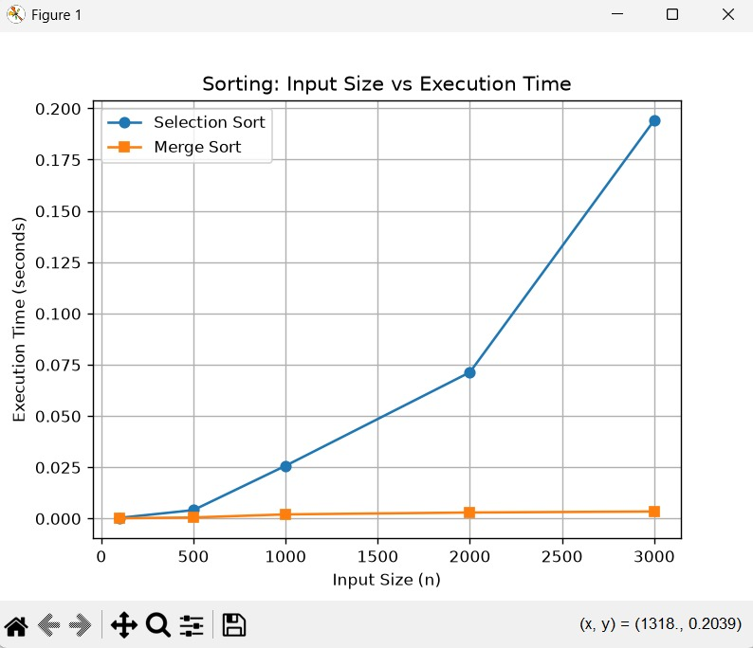

19. References
- Cormen, T. H., Leiserson, C. E., Rivest, R. L., & Stein, C. (2022). Introduction to algorithms (4th ed.). MIT Press.
- Levitin, A. (2012). Introduction to the design & analysis of algorithms (3rd ed.). Pearson.
- Knuth, D. E. (1998). The art of computer programming, Volume 3: Sorting and searching (2nd ed.). Addison-Wesley.
- Sedgewick, R., & Wayne, K. (2011). Algorithms (4th ed.). Addison-Wesley Professional.
- Goodrich, M. T., Tamassia, R., & Goldwasser, M. H. (2014). Data structures and algorithms in Java (6th ed.). Wiley.
- Python Software Foundation. (2026). Python 3 documentation. Python documentation
- Hunter, J. D. (2007). Matplotlib: A 2D graphics environment. Computing in Science & Engineering, 9(3), 90–95. https://doi.org/10.1109/MCSE.2007.55
- National Institute of Standards and Technology. (n.d.). Algorithms and data structures. NIST

